Chapter 9: Pythagoras' theorem and trigonometry

Worksheet B

1 For the following right-angled triangle, write down the following ratios.
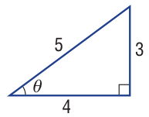
a sin θ

________________________________

________________________________

b cos θ c tan θ

________________________________ ________________________________

________________________________ ________________________________

2 Find the value of the unknown length (x) in these right-angled triangles, correct to two
decimal places.

a b
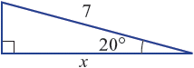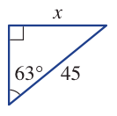

________________________________ ________________________________

________________________________ ________________________________

________________________________ ________________________________

c d
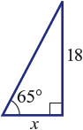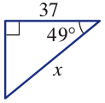

________________________________ ________________________________

________________________________ ________________________________

________________________________ ________________________________
3 Find θ in the following right-angled triangles, to the nearest degree where necessary.

a b
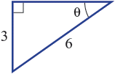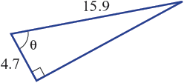

________________________________ ________________________________

________________________________ ________________________________

4 The angle of depression of a point on the ground from the top of a 25 m tower is 30°.
How far away, correct to two decimal places, is the point from the base of the tower?

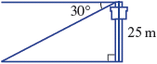
________________________________

________________________________

________________________________

5 The altitude of an aeroplane is 0.8 km, and the horizontal distance from the aeroplane
to the runway is 3 km. Find the angle of elevation from the runway to the aeroplane, to
the nearest degree.
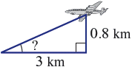
________________________________

________________________________

________________________________

6 A walker leaves camp (C) and walks on a bearing of 210°T for 7 km. How far
west of camp (x km) is the walker?

______________________________________________________________________

______________________________________________________________________

7 A bushwalker walks 6.4 km on a true bearing of 135° from point A to point B. Find
how far East point B is from point A, correct to two decimal places.

______________________________________________________________________

______________________________________________________________________

